**Water Table 3–Delivering on our water positive target by enabling access to water and sanitation services, and through water replenishment projects**

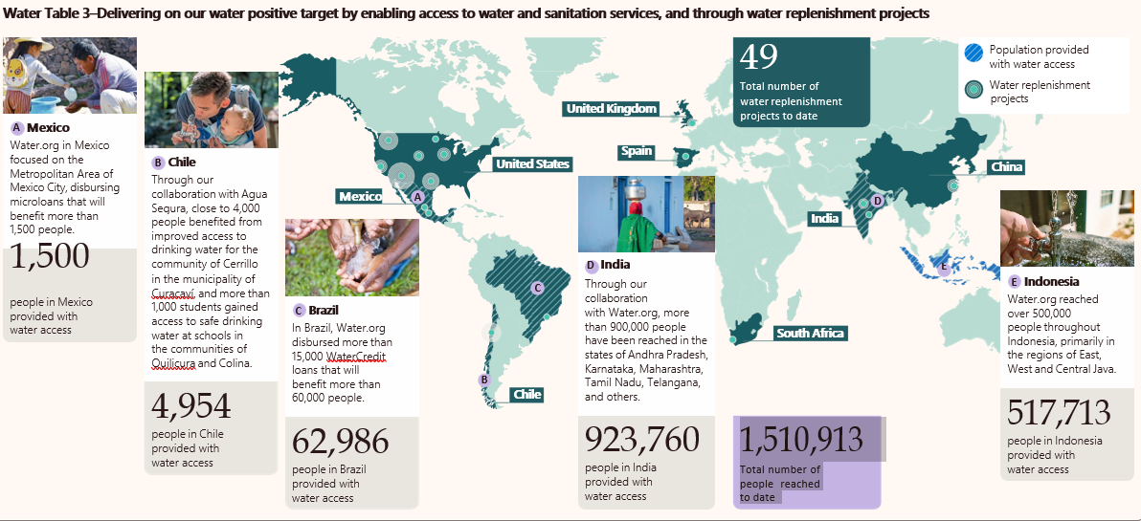

Illustration of a world map with demarcations highlighting (A) Mexico, (B) Chile, (C) Brazil, (D) India, and (E) Indonesia. Mexico, Chile, Brazil are marked as Population provided with water access and some regions are marked as regions with Water replenishment projects.

Water.org in Mexico focused on the Metropolitan Area of Mexico City, disbursing microloans that will benefit more than 1,500 people.

**Mexico:** Water.org in Mexico focused on the Metropolitan Area of Mexico City, disbursing microloans that will benefit more than 1,500 people. 1,500 people in Mexico provided with water access.

**Chile:** Through our collaboration with Agua Segura, close to 4,000 people benefited from improved access to drinking water for the community of Cerrillo in the municipality of Curacaví, and more than 1,000 students gained access to safe drinking water at schools in the communities of Quilicura and Colina. 4,954 people in Chile provided with water access

**Brazil:** In Brazil, Water.org disbursed more than 15,000 WaterCredit loans that will benefit more than 60,000 people. 62,986 people in Brazil provided with water access

**India:** Through our collaboration with Water.org, more than 900,000 people have been reached in the states of Andhra Pradesh, Karnataka, Maharashtra, Tamil Nadu, Telangana, and others. 923,760 people in India provided with water access

**Indonesia:** Water.org reached over 500,000 people throughout Indonesia, primarily in the regions of East, West and Central Java. 517,713 people in Indonesia provided with water access

1,510,913 Total number of people reached to date through water replenishment projects.